DATA ANALYSIS INTERNSHIP – DAY 18 REPORT
Organization: Top Tech Developers
Topic Covered: Sales & Revenue Analysis Dashboard using Power BI

Introduction
Microsoft Power BI is a business intelligence and data visualization tool used to create interactive dashboards and reports. It helps organizations analyze sales, revenue, and business performance using charts, KPI cards, filters, and slicers.
On Day 18 of the internship, a Sales & Revenue Analysis Dashboard was created using Microsoft Power BI. Different visualizations were used to analyze revenue performance based on products, regions, categories, and sales dates. Interactive dashboard features and formatting techniques were also applied to improve analysis and presentation quality.

1. Dashboard Visualizations Used
Different dashboard visuals were created to represent business data effectively.

1. KPI Cards
KPI cards were used to display important business performance metrics.
KPI Values
KPI Metric | Value
Total Revenue | 330K
Total Sales | 29
Average Revenue | 32.96K
Purpose
- Displays important business insights quickly
- Provides overall sales performance summary
- Improves dashboard readability
Observation
- KPI cards simplified revenue analysis
- Important business values became easier to identify
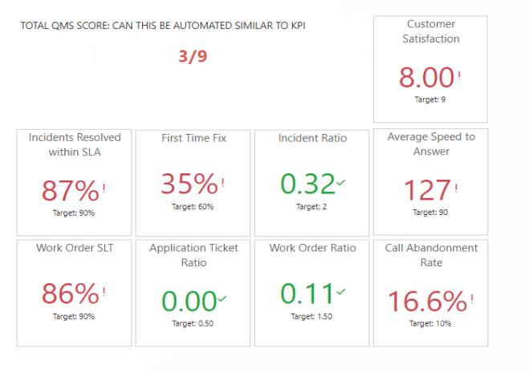
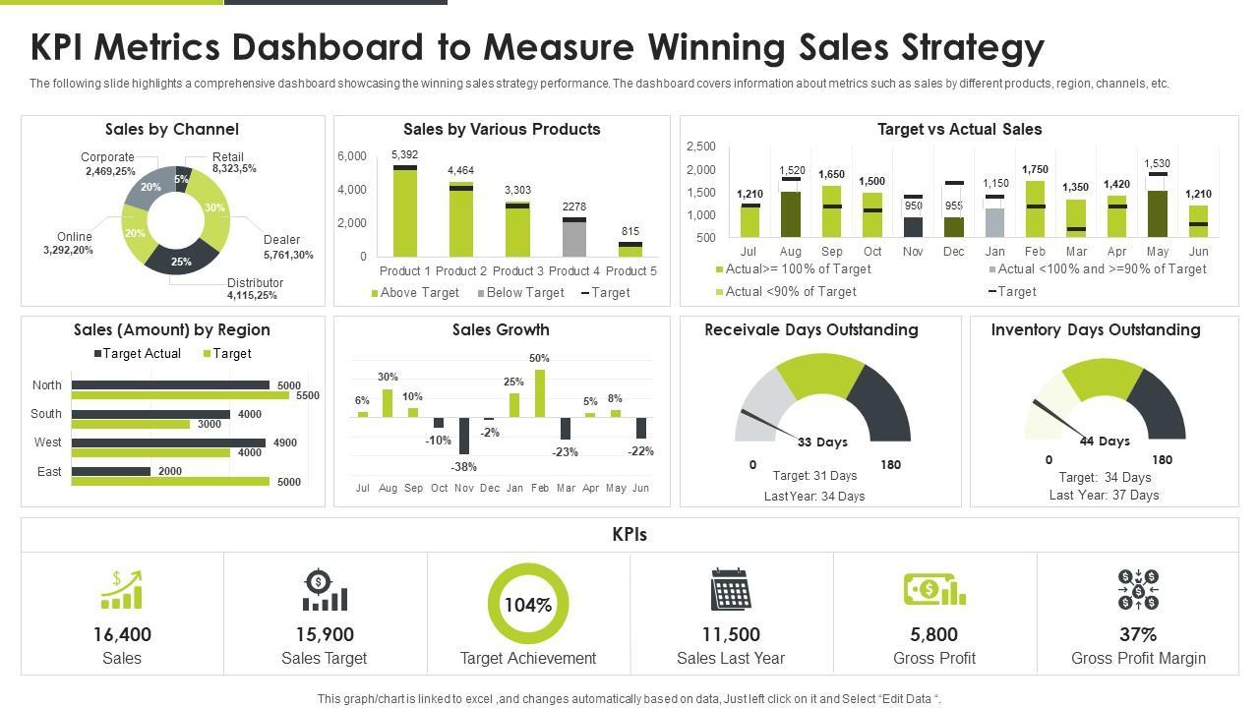
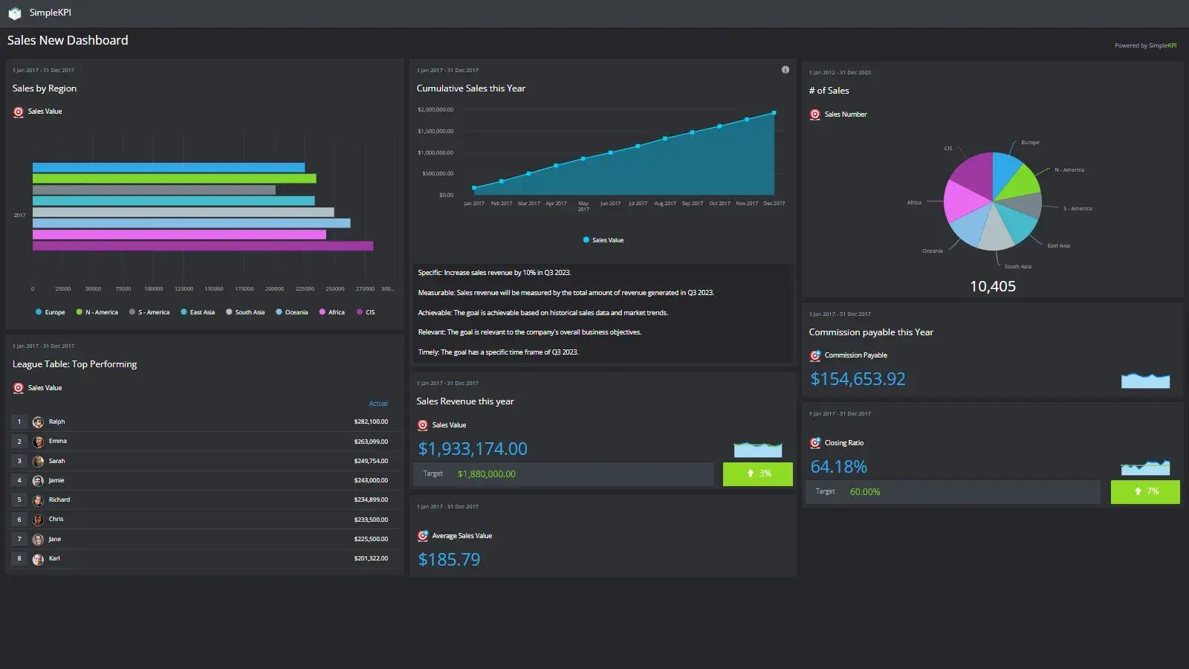
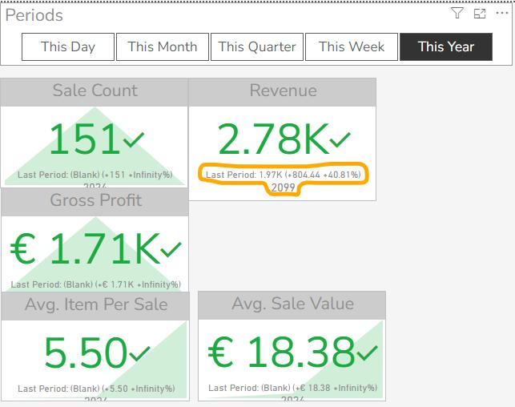
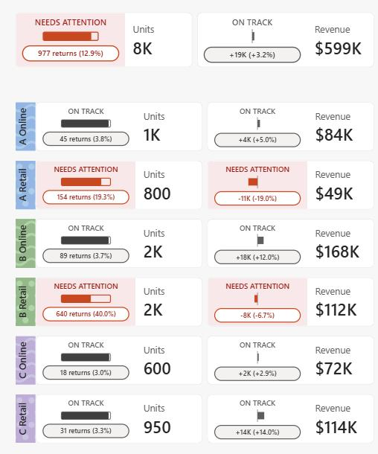
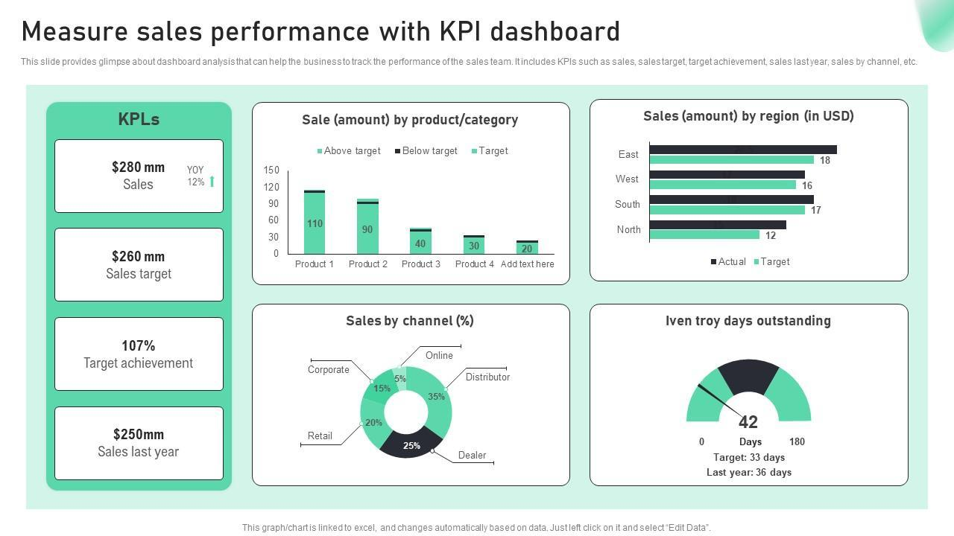

2. Bar Chart – Sum of Revenue by Product
A bar chart was created to compare revenue generated by products.
Products Included
- Laptop
- Mobile
- Tablet
- Shoes
- Headphones
- Watch
- Bag
Purpose
- Compares product-wise revenue performance
- Identifies products contributing higher sales revenue
Observation
- Laptop generated the highest revenue among all products
- Product comparison became easier through visualization

3. Bar Chart – Sum of Revenue by Region
A regional revenue comparison chart was added.
Regions Included
- Chennai
- Madurai
- Coimbatore
- Salem
- Trichy
Purpose
- Analyzes revenue contribution from different regions
- Helps identify top-performing sales locations
Observation
- Some regions generated higher revenue compared to others
- Regional analysis improved business understanding
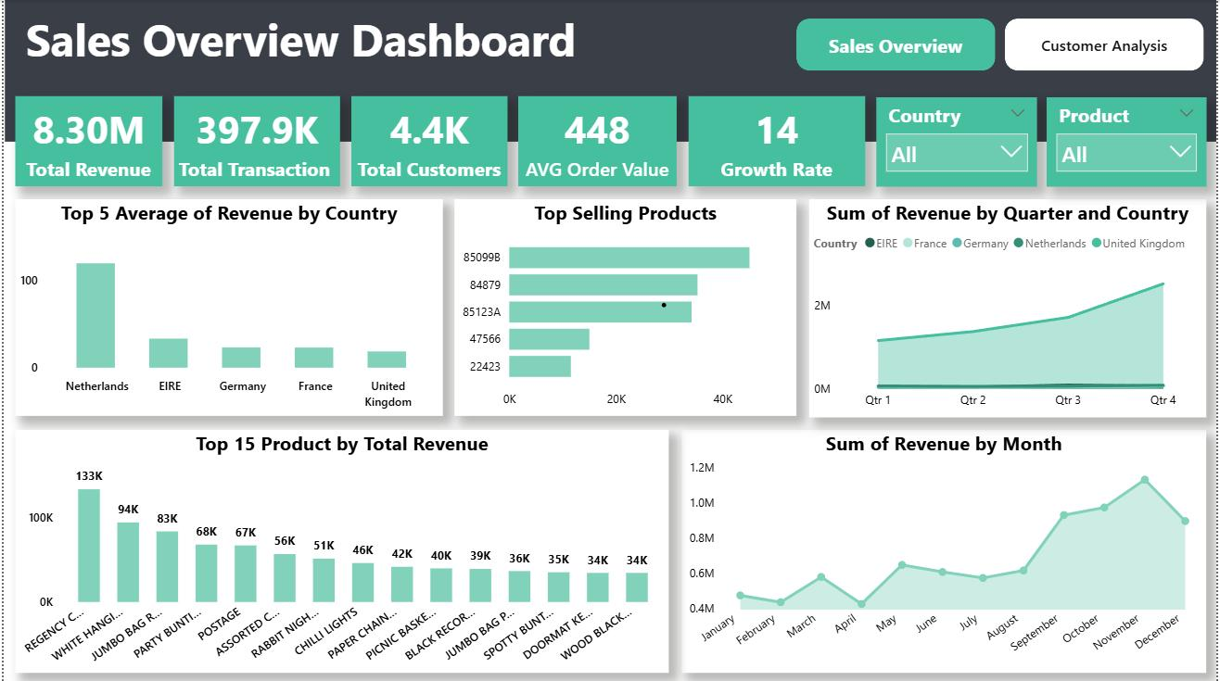
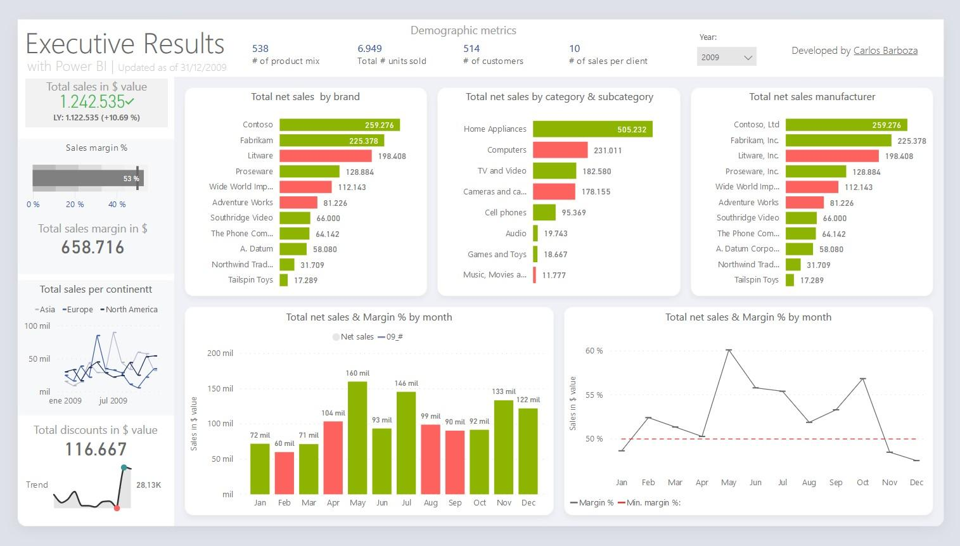

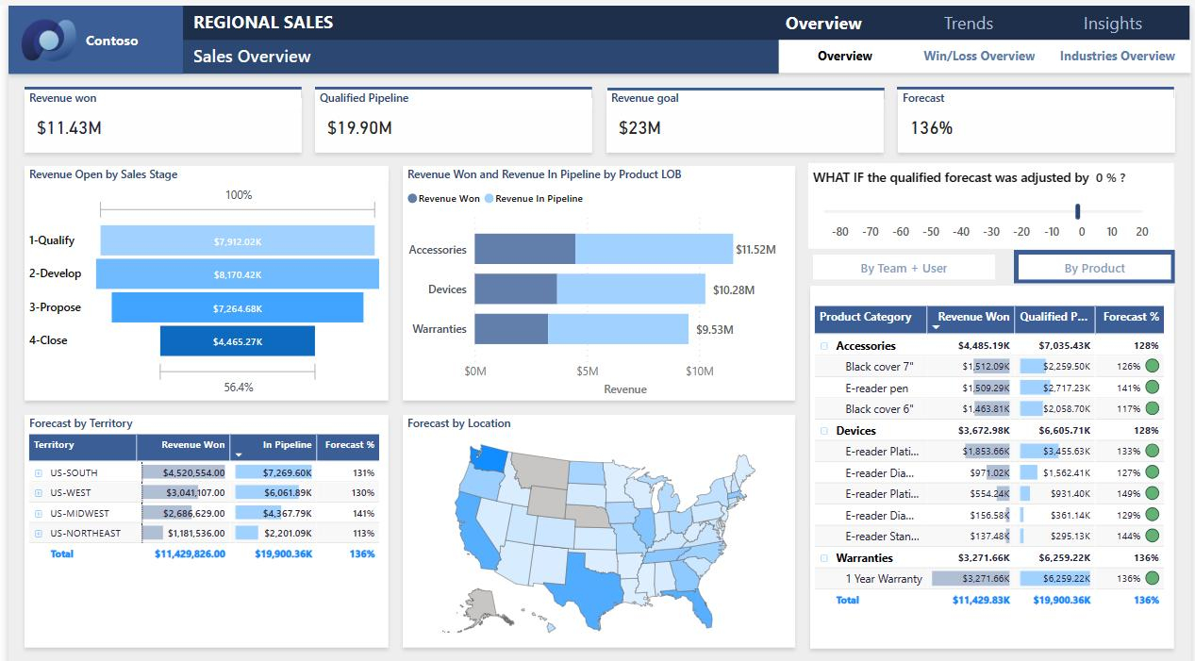
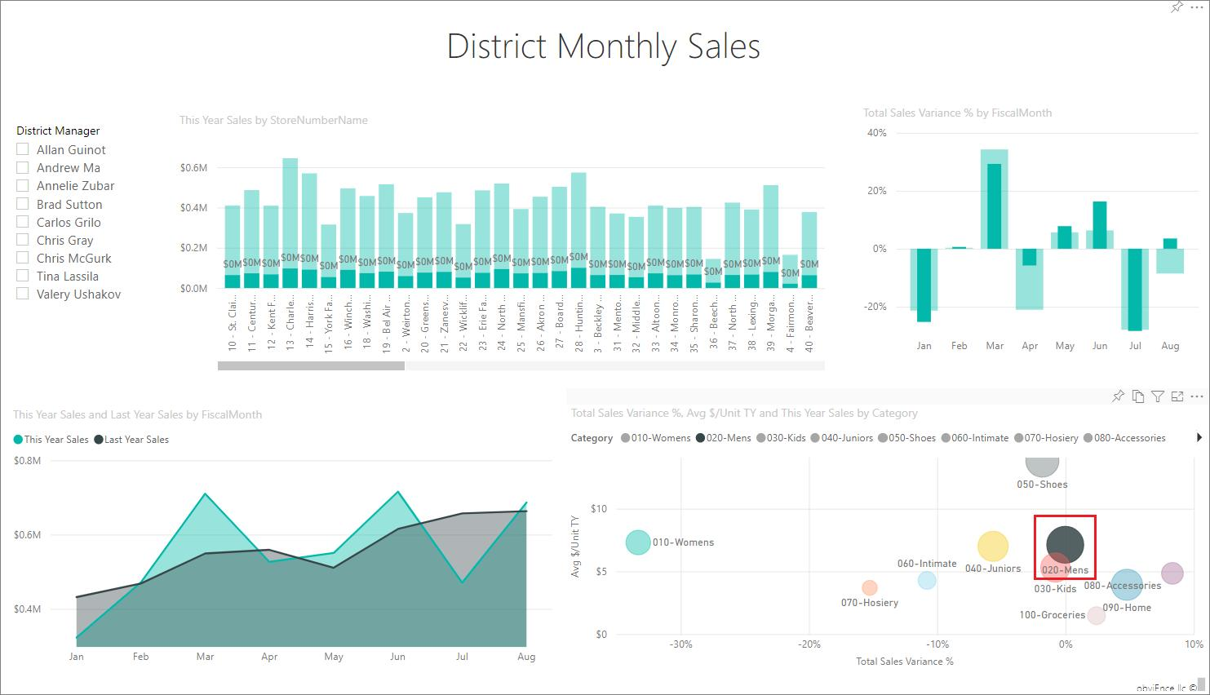

4. Pie Chart – Sum of Revenue by Category
A pie chart was created to represent category-wise revenue distribution.
Categories Included
- Electronics
- Fashion
Purpose
- Displays percentage contribution of each category
- Helps compare business categories visually
Observation
- Electronics category contributed the highest revenue percentage
- Pie chart improved category comparison and analysis

5. Line Chart – Revenue Trend Analysis
A line chart was added to analyze daily revenue trends.
Purpose
- Shows revenue increase and decrease patterns over time
- Helps identify sales trends during different dates in January
Observation
- Revenue fluctuations became easier to analyze
- Trend analysis improved business insights

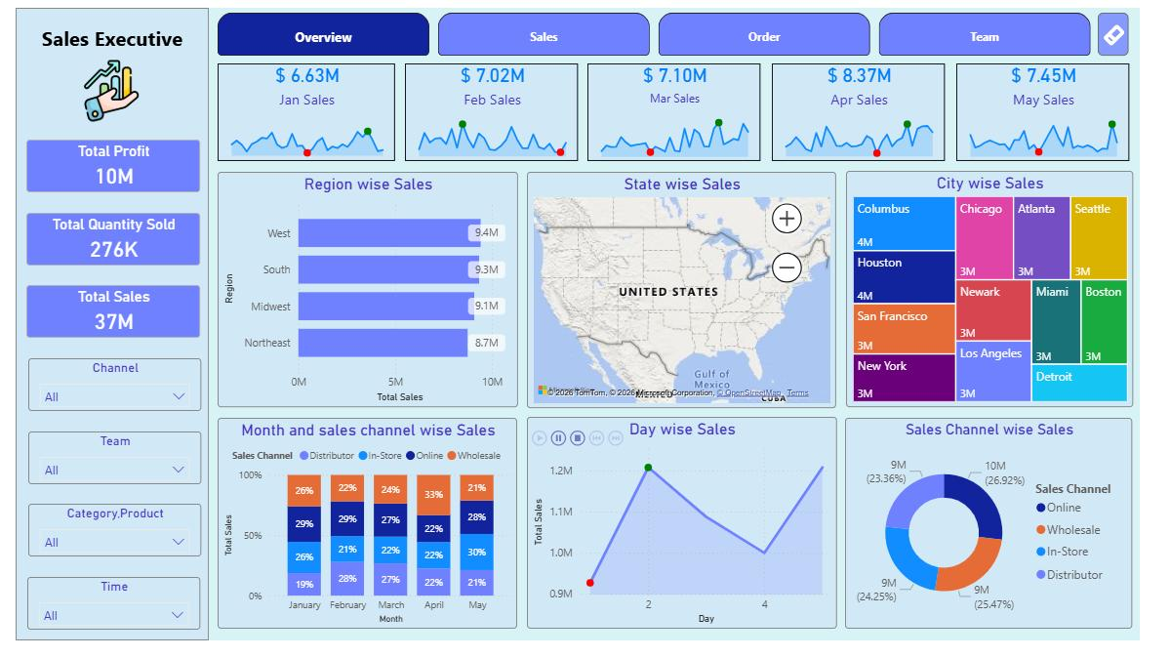
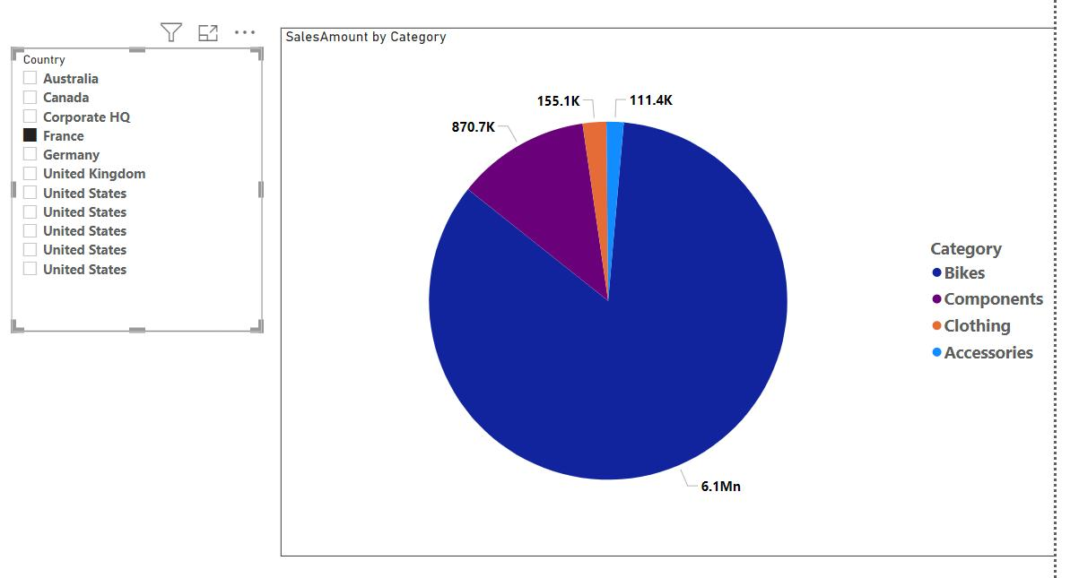
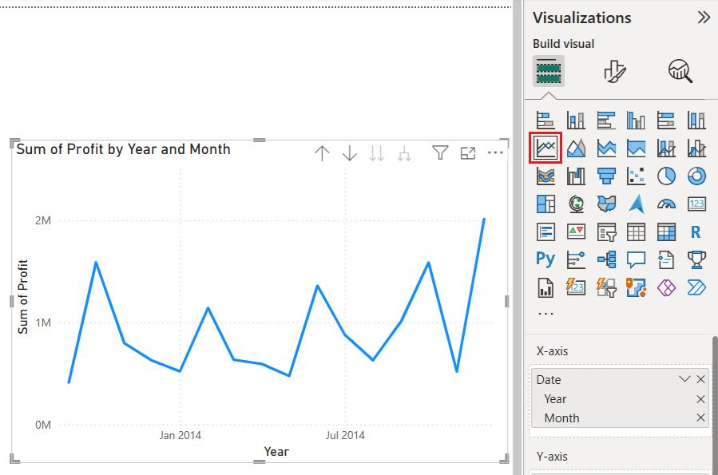
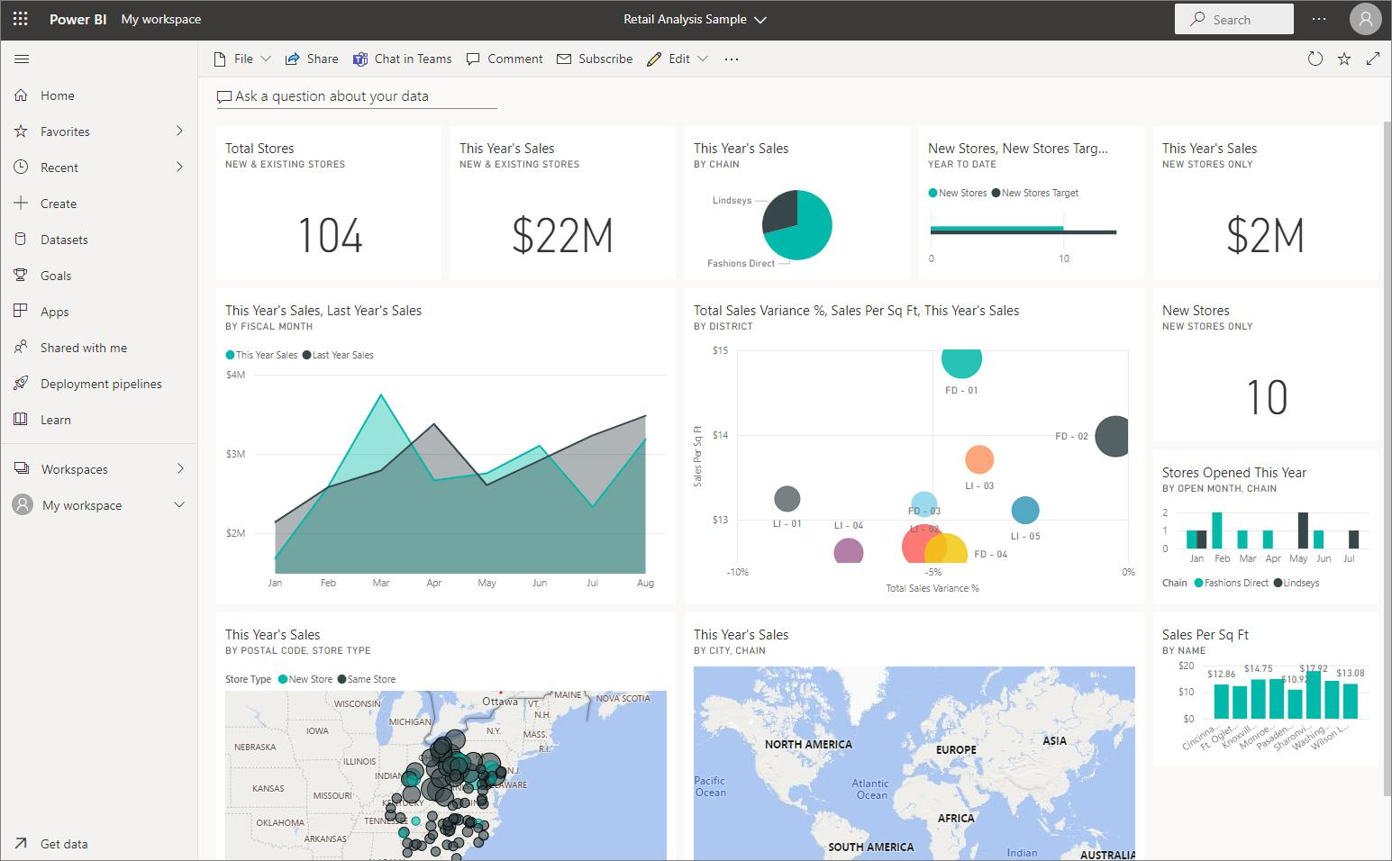
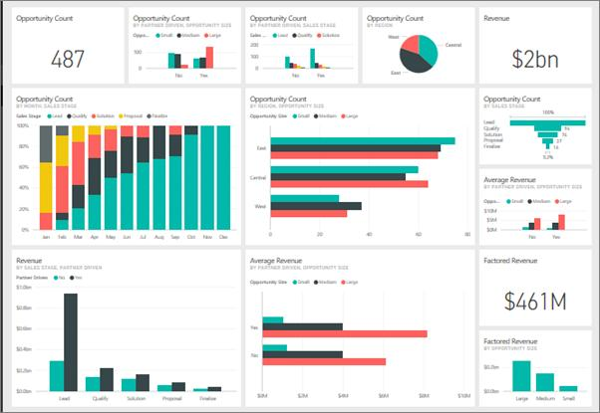

2. Interactive Features Added
Interactive dashboard features were implemented to improve user analysis experience.
Slicers and Filters
Interactive slicers were created for:
- Product
- Region
- Category
- Date
Purpose
- Allows dynamic filtering of dashboard data
- Helps users analyze selected records easily
Observation
- Slicers improved dashboard interactivity
- Users could customize analysis based on selected values

Date Range Slider
A date range slider was added for filtering records between selected dates.
Purpose
- Helps analyze data within a selected time period
- Simplifies trend-based revenue analysis
Observation
- Date filtering improved analysis flexibility
- Daily revenue trends became easier to study

3. Dashboard Design and Formatting
Different formatting techniques were applied to improve dashboard appearance and readability.
Design Features Applied
- Green-themed dashboard background
- Proper alignment of charts and visuals
- Border customization
- Visual spacing and layout organization
- Clean and interactive dashboard design
Observation
- Dashboard appearance became more attractive
- Organized visuals improved presentation quality

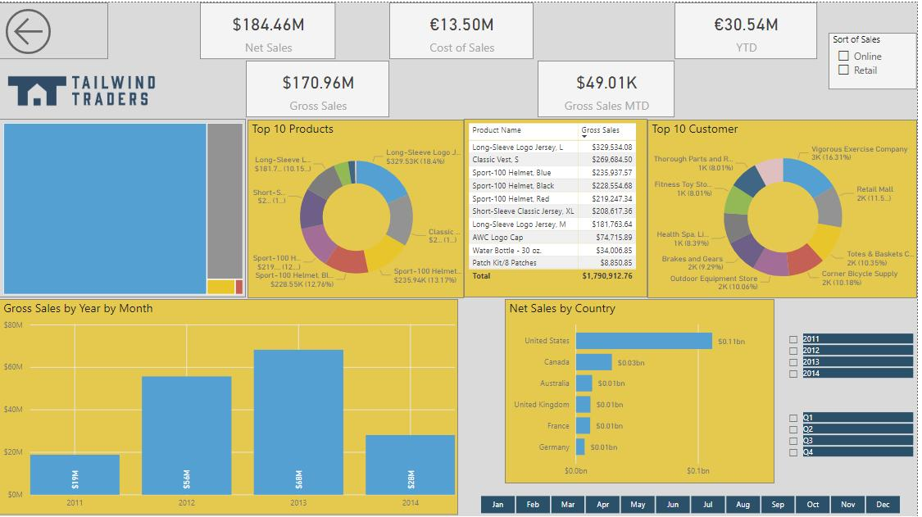
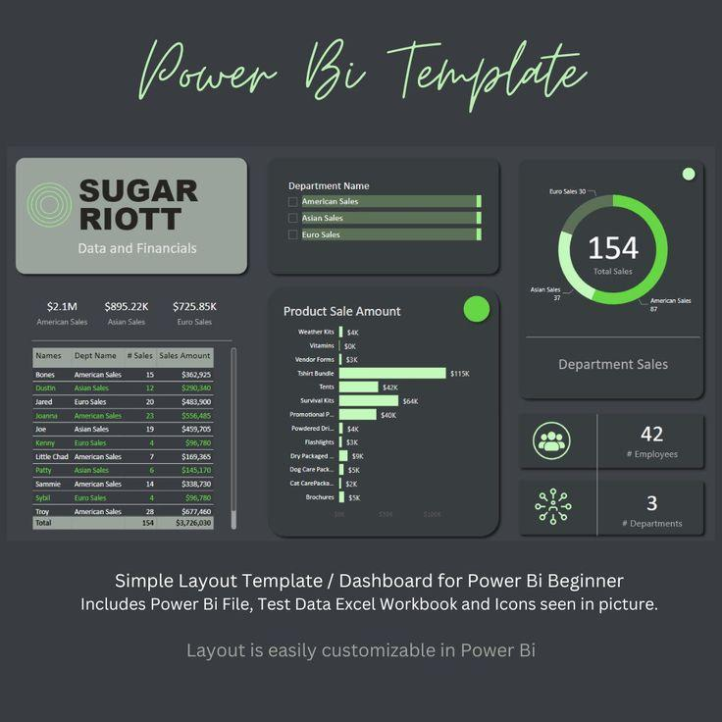

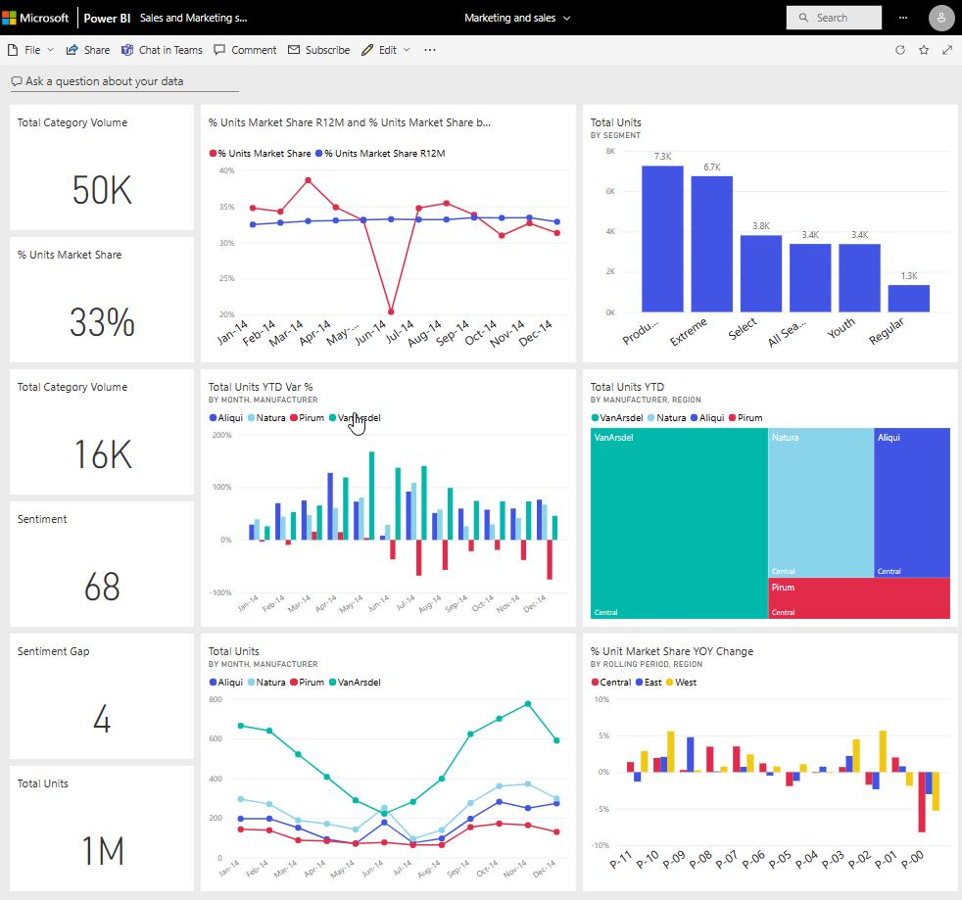

Tools Used
- Microsoft Power BI
- Microsoft Excel
- Dashboard Design
- Data Visualization
- Business Analytics

Outcome
The Sales & Revenue Analysis Dashboard was created successfully using multiple visualizations and interactive filtering techniques.
The dashboard provided insights into:
- Product-wise revenue performance
- Regional sales contribution
- Category-wise distribution
- Revenue trend analysis

Learning Outcome
On Day 18, I learned how to create interactive business dashboards using Microsoft Power BI.
I understood:
- how to create KPI cards and charts
- how to analyze sales and revenue data
- how to apply slicers and filters
- how to improve dashboard formatting and design
- how visual dashboards help in business analysis and decision-making

Conclusion
The Day 18 internship session helped me improve my practical knowledge of business intelligence and dashboard visualization using Microsoft Power BI.
Different visualizations such as KPI cards, bar charts, pie charts, and line charts were created successfully for sales and revenue analysis. Interactive slicers, filters, and date range selection improved dashboard usability and analysis efficiency. This session enhanced my understanding of business data visualization, dashboard formatting, and interactive reporting techniques.

